**Document 4**

**Project Name:** Hospital Network Design

**Group:** 1

**Module:** DMT2d

**Team members:** Tshifhiwa Letlalo

Given Mogowe

Fahima Patel

Lebohang Marina Shai

**Table of contents**

**Floor plan** ……………………………………………………………………………………………………………………….3

**Simulation** ………………………………………………………………………………………………………………………4

**IP Address Table** ……………………………………………………………………………………………………………..5

**Network Topology** …………………………………………………………………………………………………………..6

**Network Diagram** ………………………………………………………………………………………………..………….7

**WBS** …………………………………………………………………………………………………………………………………8

**Gantt Chart** ……………………………………………………………………………………………………………………..9

**Intranet site** …………………………………………………………………………………………………………………….10

**Floor Plan:**

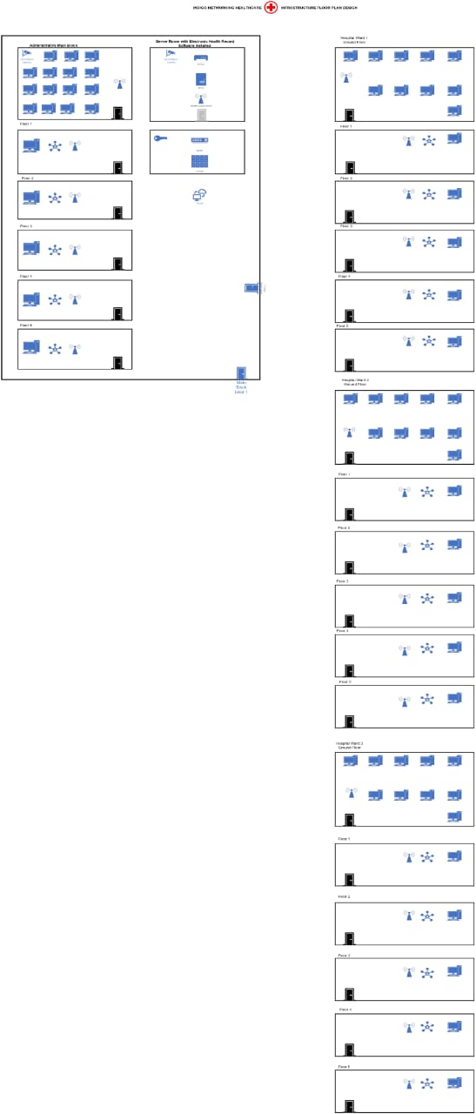

**Simulation:**

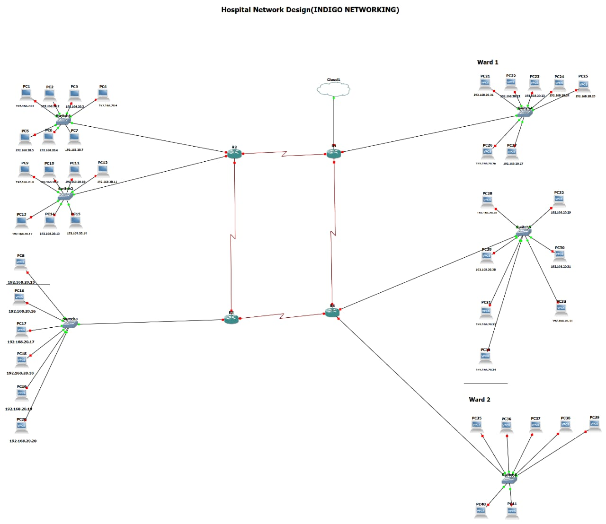

**Simulation Recording:**



**IP Address Table:**



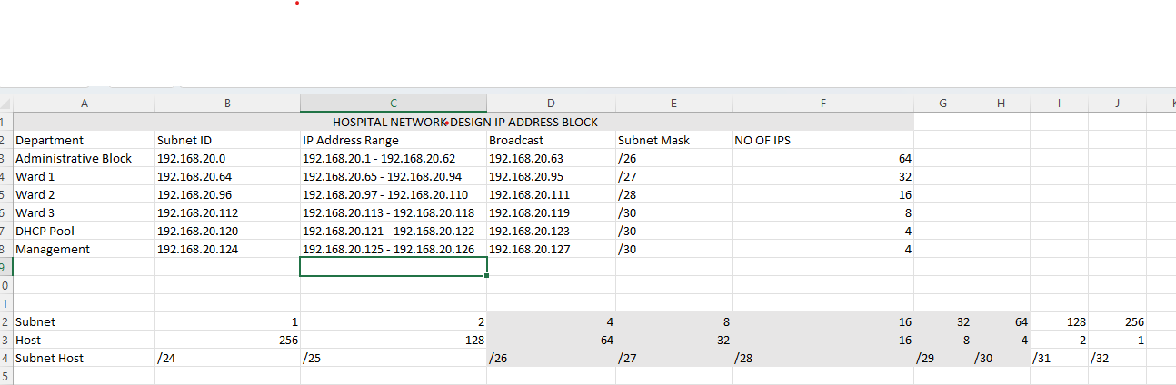

**Network Topology:**

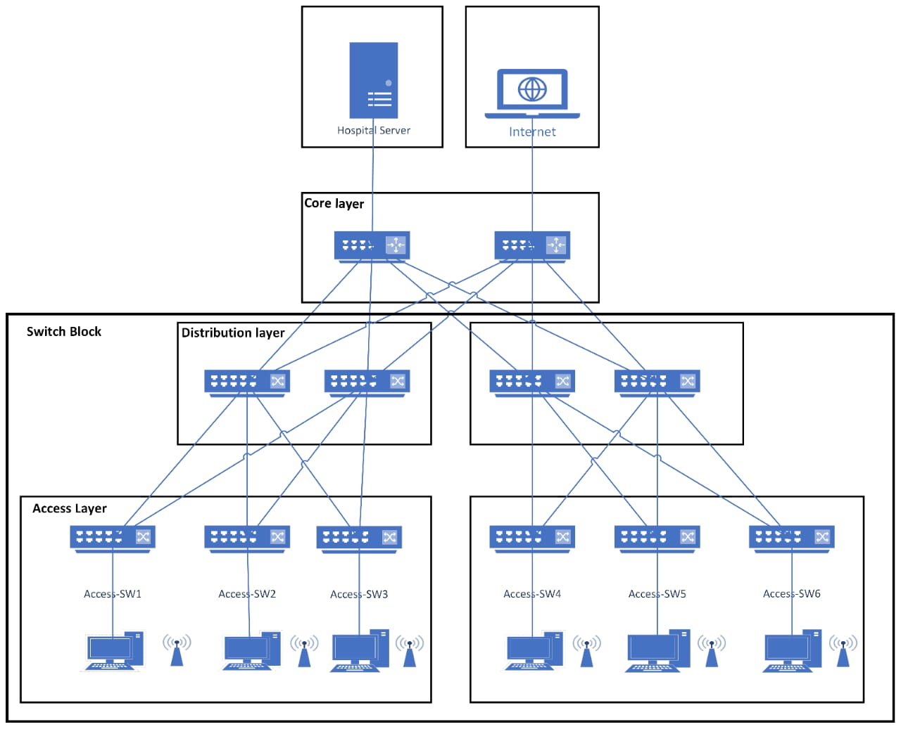

**Network Diagram:**

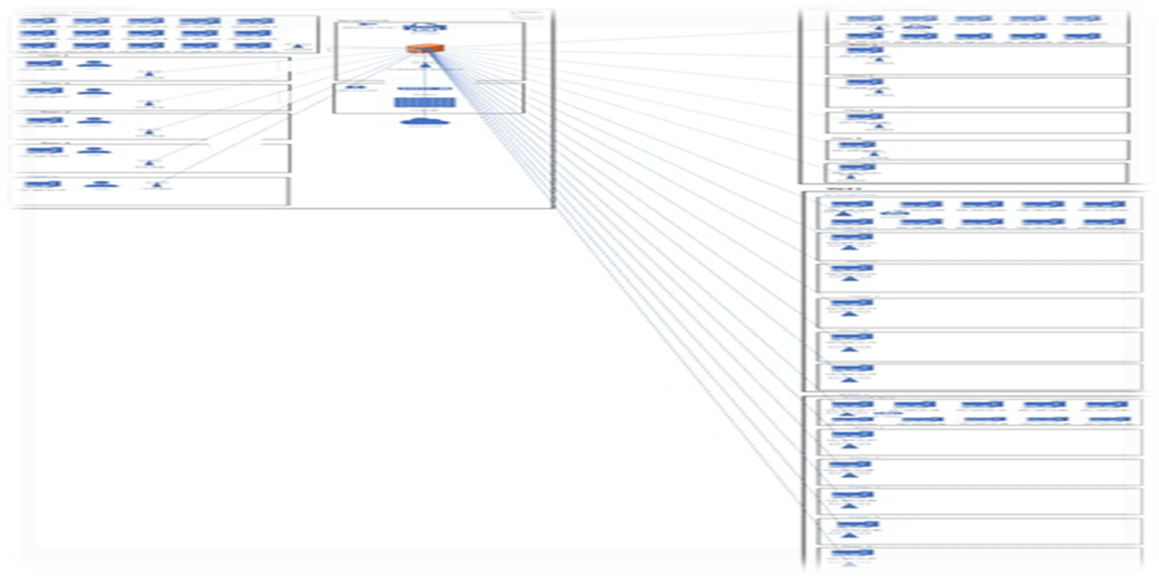

**Work Breakdown Structure:**

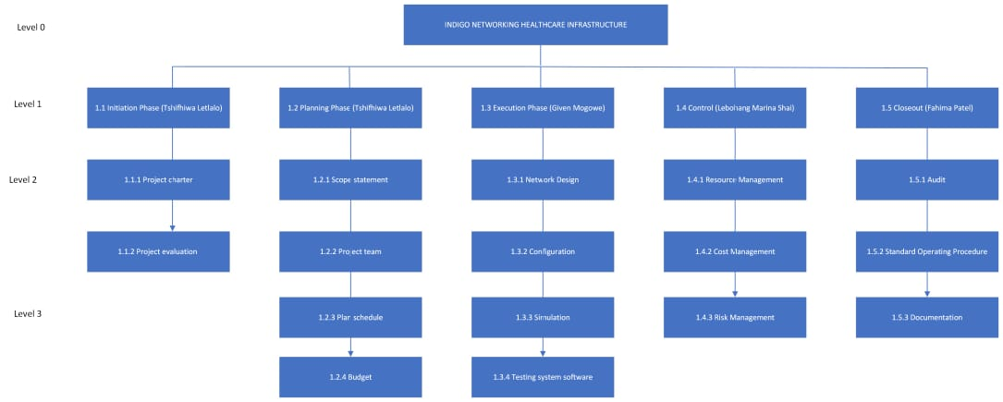

**Gantt chart:**



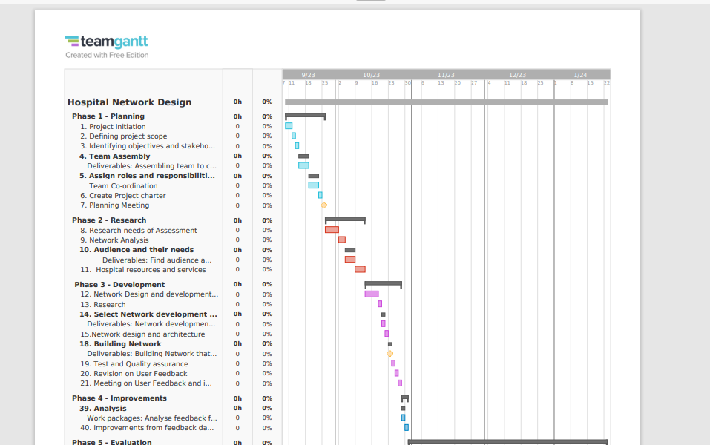

**Intranet site:**



